|  |
| --- |
| Web Technologies |
| The Dark Descent |
| Part 1 Report |

|  |
| --- |
| Paul Crichton - 40435990  3-2-2021 |

Contents

Nessesary Information 3

Introduction 3

Story 3

Introduction 4

Story 4

Technical 4

Visuals 4

Introduction 5

Navigation Tree 5

Site map 5

Buttons 6

Choices 6

Undo Choice 6

Restart 6

End 6

Background 6

Image 6

Background 6

Introduction 7

Example Page – In the Cavern 7

Colour 7

eXAMPLE iMAGES **Error! Bookmark not defined.**

Background 9

Buttons 9

Color 9

Works Cited 10

tHE dark Descent

# Nessesary Information

1. Name – Paul Crichton
2. Student Number – 40435990
3. Email – [40435990@live.napier.ac.uk](mailto:40435990@live.napier.ac.uk)
4. Class – Web Tech, SET08101
5. Game Name – The Dark Descent

# Introduction

The game that I am planning to create falls under the Dark Fantasy genre which is a sub-genre of Adventure Fantasy. Players will all start at the same beginning but depending on their choice’s players can end the game at different epilogues. The epilogues are split into two, “False” and “True” epilogues with the game having fewer of the latter. In the game a “False epilogue” is an ending that cuts the story short whereas a “True epilogue” is an ending that concludes the story. The visual elements of the game will be based upon retro arcade games.

# Story

The games story is about a character who awakens to find themselves in a dark cave that they must traverse to find an exit. There is a “boss” monster that may or may not impede the character in their journey through the cave system. There are many endings but only a few true endings that the character may or may not survive in. Main inspirations for the game come from other similar games such as Eternal (Master, n.d.), and Dreamtruder (Mystic_Warrior, n.d.). An example playthrough is included at the end of the report.

Research

# Introduction

The following is a quick summary of parts of my research that I found particularly important. Full citations are included in the bibliography at the end of the report.

# Story

The chosen genre was investigated through the playing of other games in the genre or those of a similar nature. Some included Eternal (Master, n.d.), Dreamtruder (Mystic_Warrior, n.d.), and Death Song (Master, n.d.). From these sources I concluded that the genre required a few key aspects such as a level of uncertainty or an overarching villain.

# Technical

As I was unfamiliar with CSS I choose to use Stack Overflow to increase my understanding this is what inspired my use of <span> instead of the usual HTML <button> tag as I found I could create better looking designs using the tag. It also showed me that if I had be submitting a form it would have been more appropriate to use a button but for only hyperlinks span would be sufficient (Quentin, 2017).

# Visuals

Since the game will require interactive buttons to navigate between choices, I choose to spend time researching button designs that might influence my own design. Some that I found particularly influential (Figure 7) were Daniel Weiner’s on codepen.io (DanielWeiner, 2021) whose design mimicked the design of a classic Gameboy controller.

Navigation

# Introduction

The website will be organized into different pages that each represent either a scenario with choices, a normal ending, or a true ending. Each scenario page will contain buttons with hyperlinks to the corresponding page. Each ending will include a return to start button instead of choices. Below are examples using 2 different “True Endings” and multiple false endings. In Figure 1 the choices are shown using labeled lines to show how each choice can lead to a different ending/scenario. In Figure 2 what is shown represents a more traditional site map. The end-product may have more or less endings.

# Navigation Tree

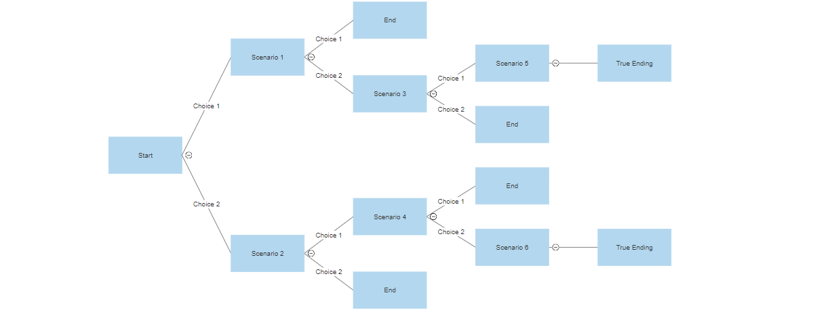

Figure

# Site map

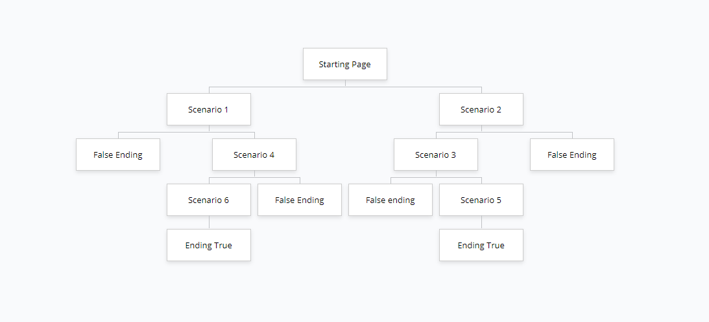

Figure

Key Features

# Buttons

## Choices

The choice buttons are used to take the user forward in the story they link to another page with the results/consequences of the choice made. They are large and “clickable” to mimic those of a Gameboy or other arcade system.

## Undo Choice

The undo choice button is a link to the previous scenario. This is there in case the user makes the wrong choice accidentally or if they regret the original choice they made.

## Restart

This button takes the user back to the beginning of the game if they are bored of the current playthrough or if they simply want to make a completely new set of choices

## End

This button is used to exit the game midway through a playthrough.

# Background

## Image

The image does not take up the full screen, it purposely is only behind the game text to imitate the design of an old retro game machine when touchscreen was not commonplace.

## Background

The rest of the background is a single block color (Grey) to imitate the plastic shell that would be on a Gameboy.

Sketching

# Introduction

Figure 3 is a rough sketch of the layout of a single page in the game. The sketch is supposed to mimic a screen with “physical buttons” below. The sketch is simple in design but corresponds to the scenarios in the game. This includes the use of a related background image (Figure 4) that changes depending on the location of the scenario (Figure 4 (Vecteezy, n.d.)Figure 5 (Vecteezy, n.d.)- Figure 6 (Vecteezy, n.d.)). The buttons are placed at the bottom of the page and are clearly separated to ensure the user knows which choice is which. To separate the types of buttons “management” buttons are placed at the top right of the screen. Possible future additions may include a return to start button or a section to clearly describe each choice instead of only a couple words.

Example Page – In the Cavern

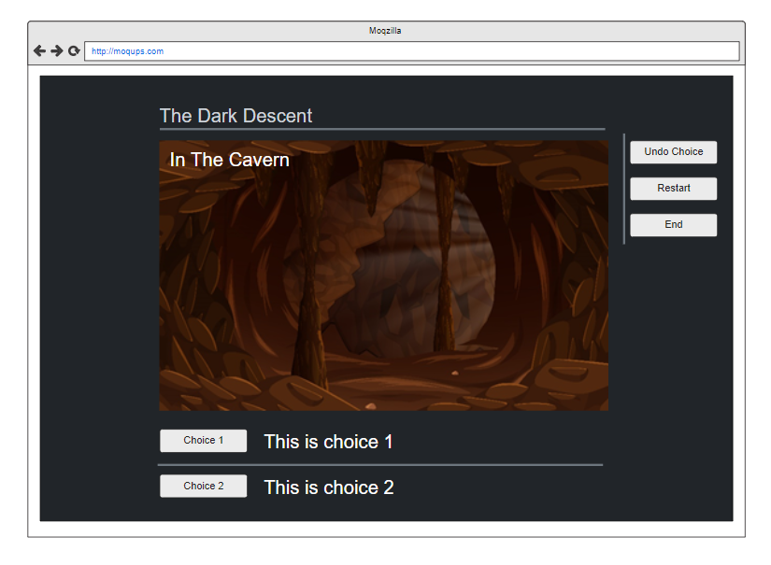

Figure

# Colour

Background color has been inspired by genre of the game. Dark colors are used to initiate a gloomy and mysterious setting. The writing is white to contrast it from the background it was also chose as it is more refined than other bright colors such as pink. This color pallet shows some example colors that I have chosen (

Figure 8).

Example Story

1. At mase start – 2-way crossroad
   1. Choice: Move forward
      1. You move forward and feel a strong wind coming from ahead of you
      2. Choice: Continue
         1. You pass a golden sword lying against the wall with no owner to be found
         2. Choice: Pick it up
            1. You continue forward until you come across a dimly lit large cavern where you can faintly see a dark shadow looming over you. The wind is strong and regular reminding you of breathing. You hear an impossibly loud question in your head. WHO ENTERS MY CHAMBER?
            2. Choice: Speak

You say something and they reply with WHY ARE YOU HERE?

Choice: Say: to barging

WITH WHAT? they ask

Choice: Give Sword

They are happy with your offering and let you leave and show you the exit hiding behind them

Choice: Say nothing

They are displeased with the silence and end your life

Choice: Say: to fight

* + - * 1. Choice: Fight

You catch the creature by surprise and stab it in the eye, the sword starts to vibrate in your hands, and you notice an inscription on the handle.

Choice: Read aloud

The sword begins to glow as you are filled with power you fight harder than you have ever before killing the creature. You notice a door below the creature

Choice: Open door

You have found the exit well done!

Choice: Leave the chamber

You spend the next few weeks wandering the cave system unable to find and exit, you starve to death

Choice: Continue to fight

You are outmatched by the massive creature you are killed

* + - 1. Choice: Leave it
         1. Same as pick it up however you have no bargaining chip or tool to use all options end in death
    1. Choice: Turn Back
       1. Return: To start

aPPENDIX

# Example Image

## Background

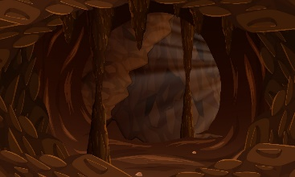

Figure (Vecteezy, n.d.)

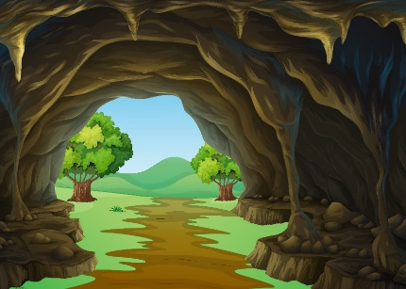

Figure (Vecteezy, n.d.)

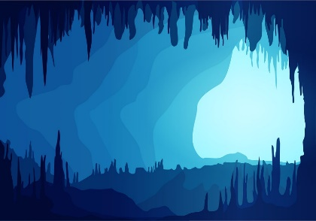

Figure (Vecteezy, n.d.)

## Buttons



Figure (DanielWeiner, 2021)

## 

## Color

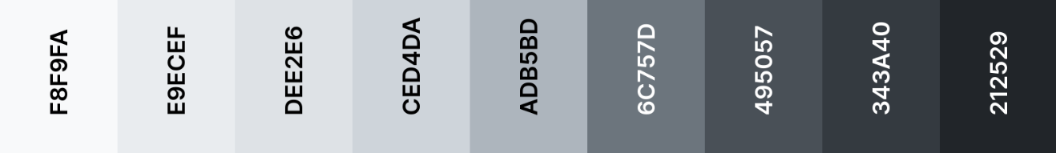

Figure (Coolors, n.d.)

Bibliography

# Works Cited

Coolors, n.d. *Coolors.* [Online]   
Available at: https://coolors.co/f8f9fa-e9ecef-dee2e6-ced4da-adb5bd-6c757d-495057-343a40-212529  
[Accessed 02 March 2021].

DanielWeiner, 2021. *codepen.io.* [Online]   
Available at: https://codepen.io/DanielWeiner/pen/iFadn

Master, E., n.d. *Choose Your Adventure.* [Online]   
Available at: https://chooseyourstory.com/story/death-song  
[Accessed 22 February 2021].

Master, E., n.d. *Choose your story.* [Online]   
Available at: https://chooseyourstory.com/story/eternal  
[Accessed 22 February 2021].

Mystic_Warrior, n.d. *Choose Your Story.* [Online]   
Available at: https://chooseyourstory.com/story/dreamtruder  
[Accessed 22 February 2021].

Quentin, 2017. *StackOverflow.* [Online]   
Available at: https://stackoverflow.com/questions/45439564/is-button-functionally-equivalent-to-span

Vecteezy, n.d. *vecteezy.* [Online]   
Available at: www.vecteezy.com  
[Accessed 2021].